Alex McLaurian
2/13/14
CS5560

Lab 3

- Mashup
My mashup used the code from the tutorials, and created a new idea. I used geolocation, and gave the user the option to save the coordinated. Saving stores the data locally, and clicking on the local weather report link makes an ajax call to the weather underground service, using the geolocation data for the api location.

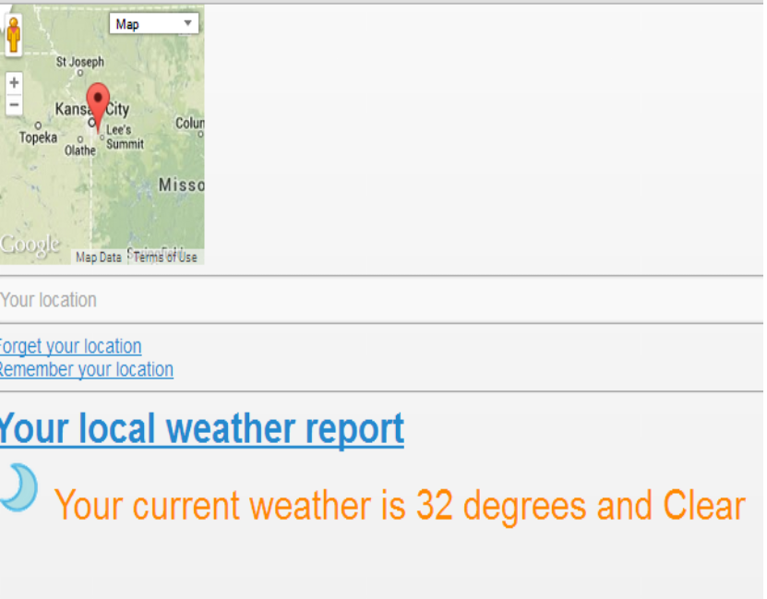

- Cloudera/MapReduce
I followed the instructions in the tutorial to download and install VMWare, then get the Cloudera image. Once everything was successfully in place, I ran word count with the given java file and data, which resulted in a successful map reduce.
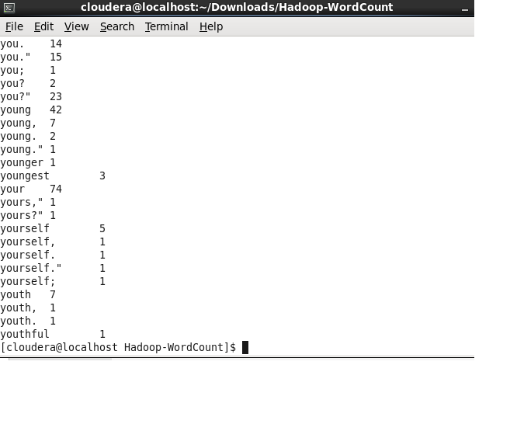

- Cloudera/Mahout

After running MapReduce, I followed the tutorial instructions on getting Mahout ready to run. I installed it, then selected the specified example data to run Mahout against:
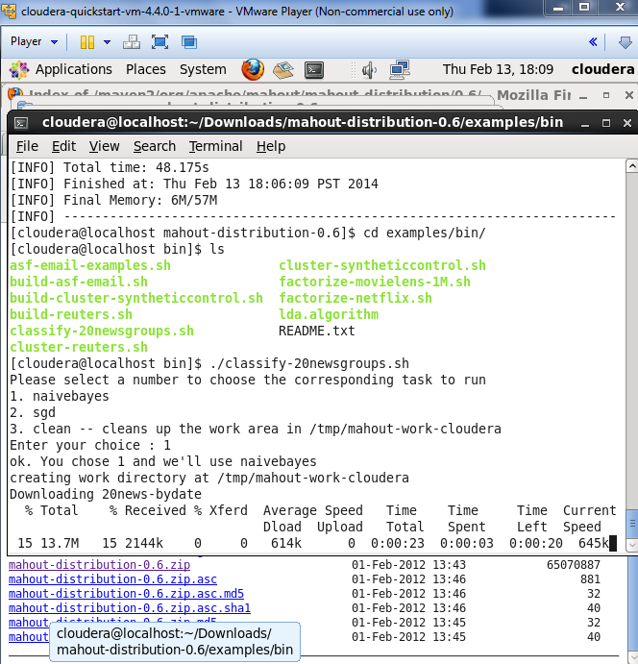
I chose the naivebayes algorithm, which after some time resulted in a successful output:
